
LAKE STEWARDS OF MAINE
VOLUNTEER LAKE MONITORING PROGRAM

Reporting Suspicious Aquatic Plants
If you think there is an invasive plant growing in your lake:
Observe and record your observations:
- When did you first notice the plant?
- Have you seen the plant in the lake in the past?
- Has it grown at a rapid rate?
- If growing in a clump or patch, how large an area does it cover?
- Is the plant growing in more than one location in the waterbody?
If you think you have found one of the eleven target invasive aquatic species in your lake, please contact the Lake Stewards of Maine.
Contact:
- The LSM at (207) 783-7733 or stewards@lakestewardsme.org
- Be prepared to give a brief description of the plant in question.
- You may be asked to collect a sample of the plant and send it to LSM for identification.
Collecting a plant specimen:
- You must be very careful when collecting a plant specimen. Fragmentation could result in an invasive plant spreading to other areas of the lake.
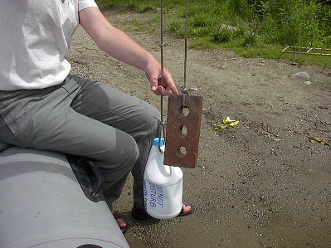
- If possible, collect several (3-5) healthy stems of the plant in question. The flower, fruits and winter buds of many aquatic plants are helpful in the identification process. If these structures are present, be sure to include them in your sample. Gently break off stem sections about 6-8” long, from the top portion of the plant. For rooted floating leaved plants, be sure to include as much of the stem as possible.
Simple marker buoy
- DO NOT attempt to pull the plant out by its roots. (This is very important!)
- Mark the location of the plant with a weighted buoy.
- If possible, mark the location on a map. A map of the waterbody may be available on the LSM website at www.lakestewardsme.org/your-lake/.
- If the plant is covered with algae or tangled in debris, remove as much of the unwanted material as possible, without damaging the specimens.
- Keep the specimens alive in a container full of water in the refrigerator until you are ready to ship them.

Preparing specimens for mailing:
- Place wet specimens in a water-tight plastic bag, (e.g., Ziploc).
- If the plant is delicate and/or flimsy, add enough water to the bag to cushion the plant and keep it wet.
- If the plant is relatively sturdy, remove all air from the bag and seal. DO NOT wrap the plant in a wet paper towel or other absorbent material.
- Make sure the bag is sealed tight and place it in a small box with enough packing material to prevent movement. Cardboard mailing envelopes are fine for sturdy specimens that are not packed in water. Padded envelopes do not work well for plant specimens.
- Include a Suspicious Plant Form in the box with the specimens. It can be downloaded online at www.lakestewardsme.org/reporting-aquatic-species-6/. This information is critical to tracking plants sent in for identification, and ensuring a timely response.
- Mail the specimen on a Monday or Tuesday, to minimize the possibility of weekend delays. Please contact LSM at (207) 783-7733 or stewards@lakestewardsme.org to let us know the specimen is on its way. We will be looking for it.
Send packaged specimens to:
Lake Stewards of Maine
24 Maple Hill Road
Auburn, Maine 04210
Response:
We will contact you within 72 hours of receiving your plant sample. We will identify the plant and confirm whether or not it is an invasive species. If the plant is invasive, the Maine Department of Environmental Protection will be notified, and a rapid response action plan will be initiated.
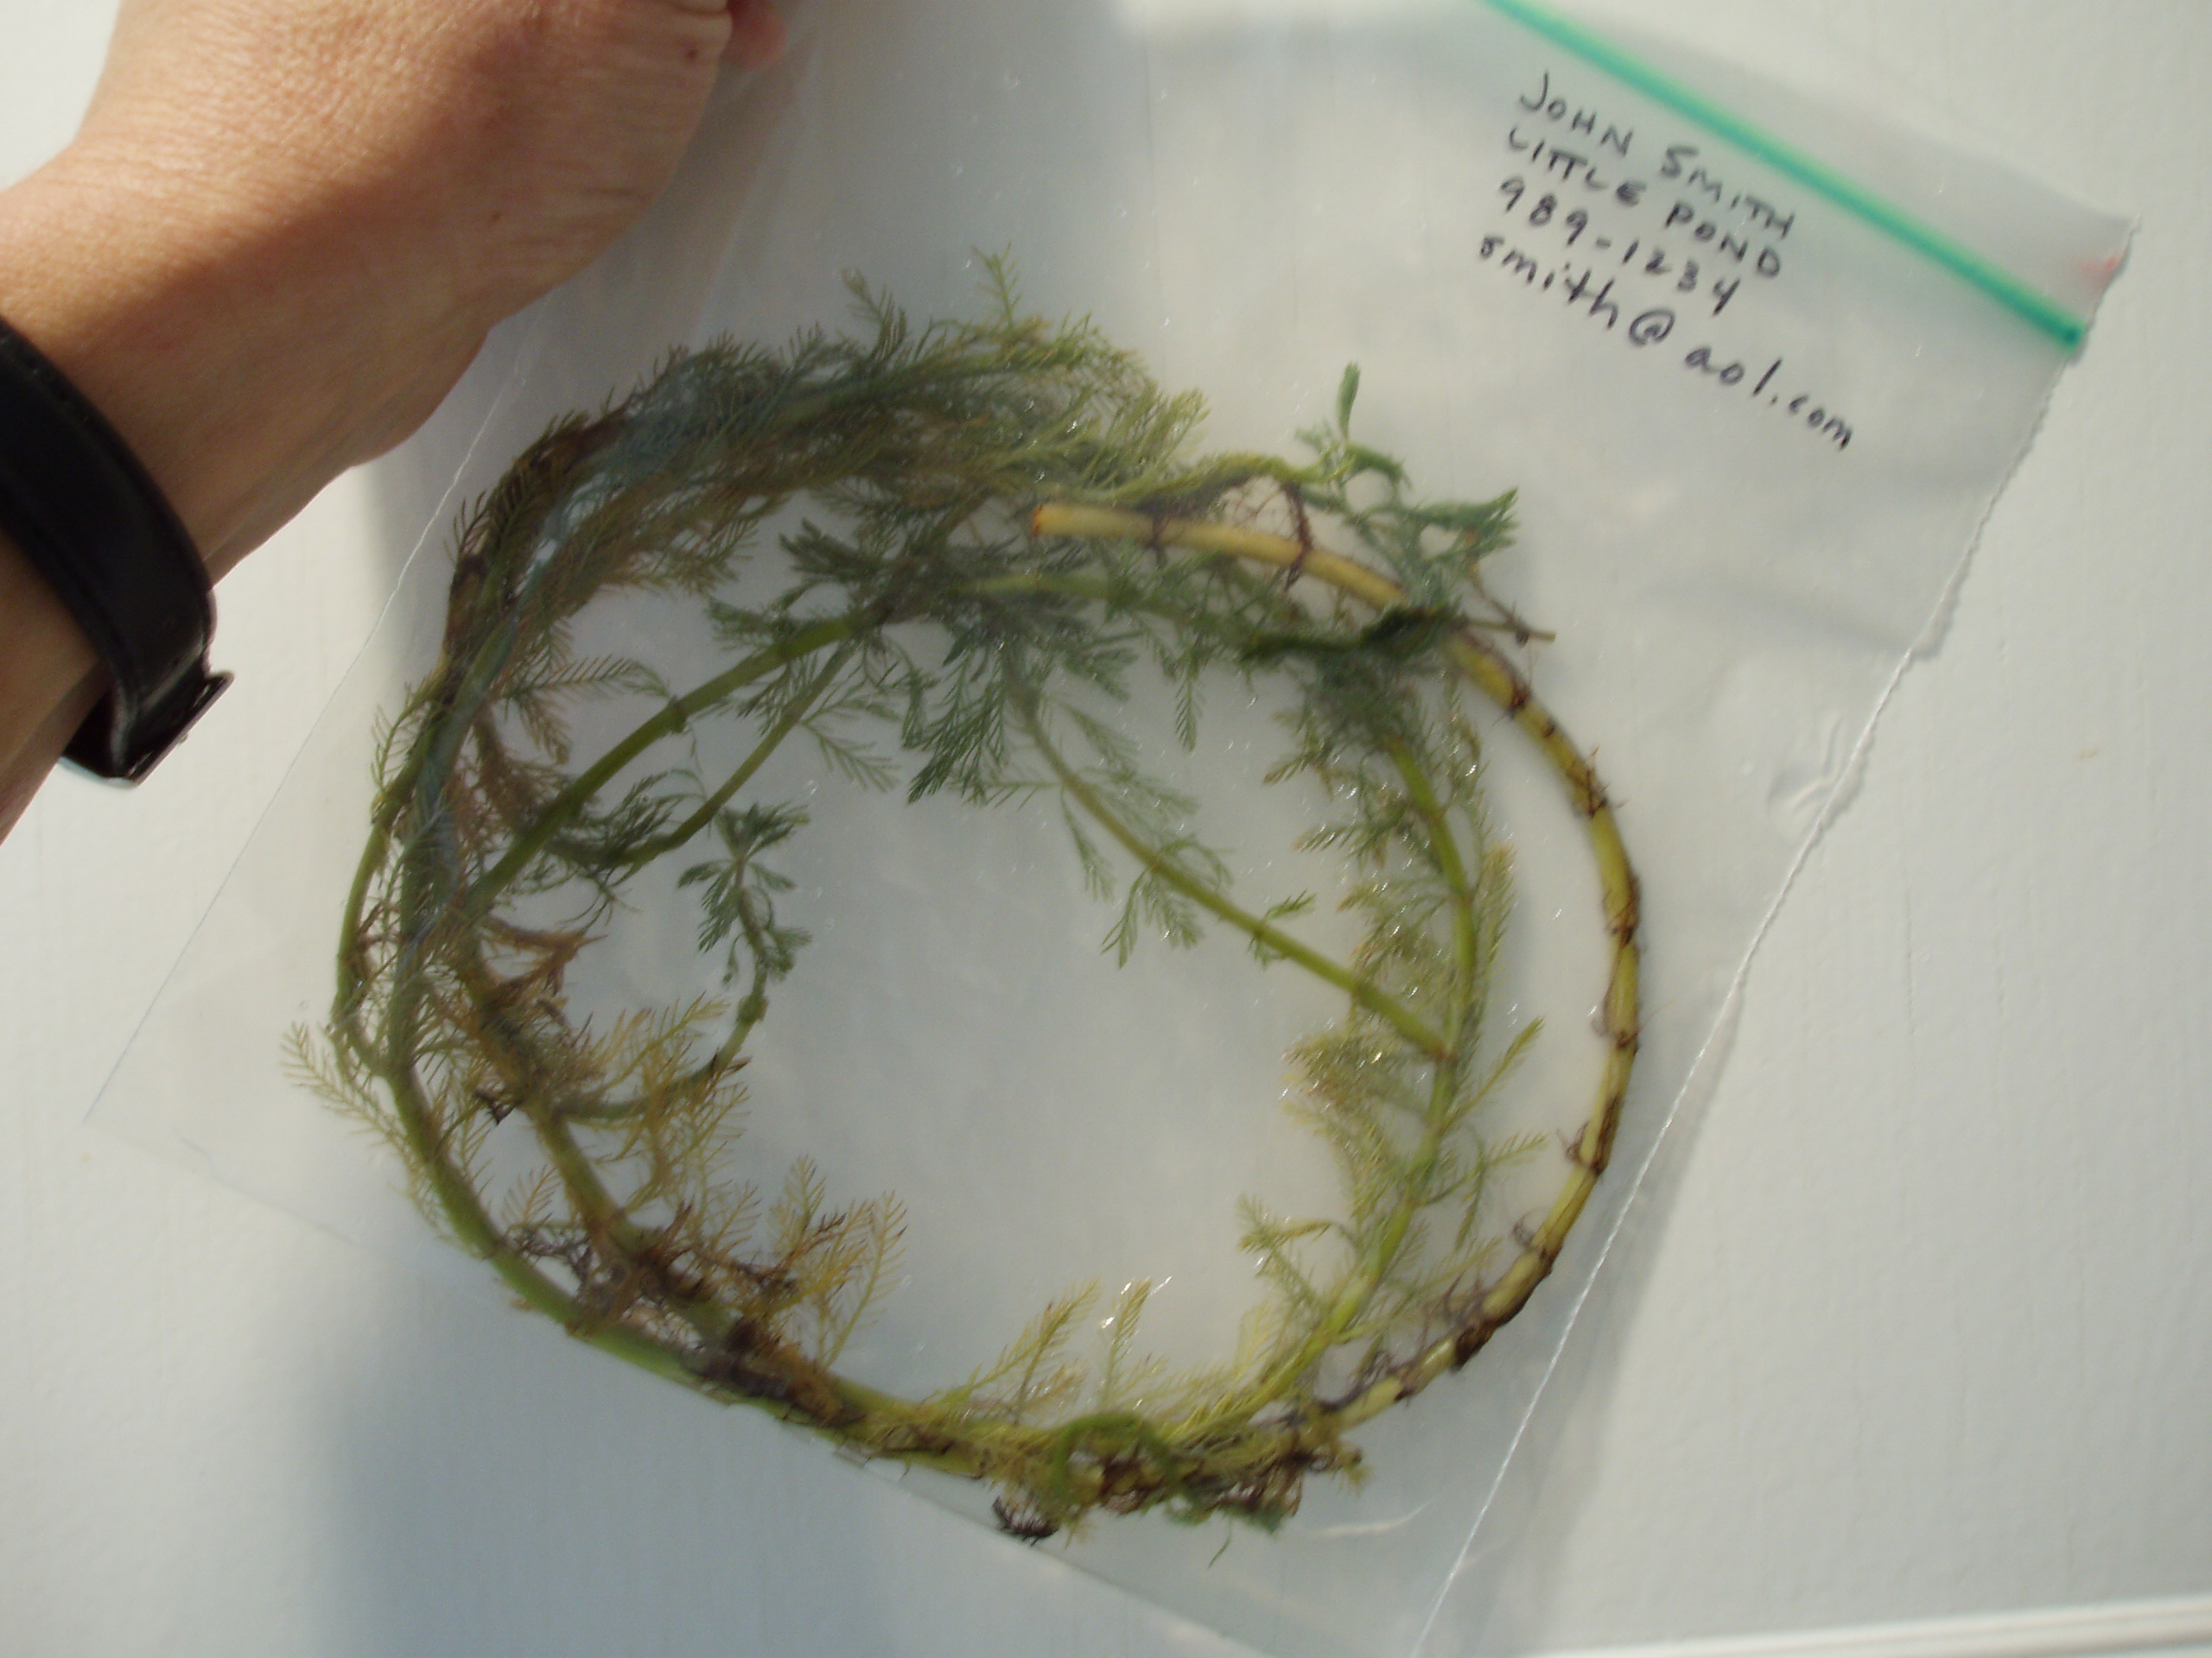
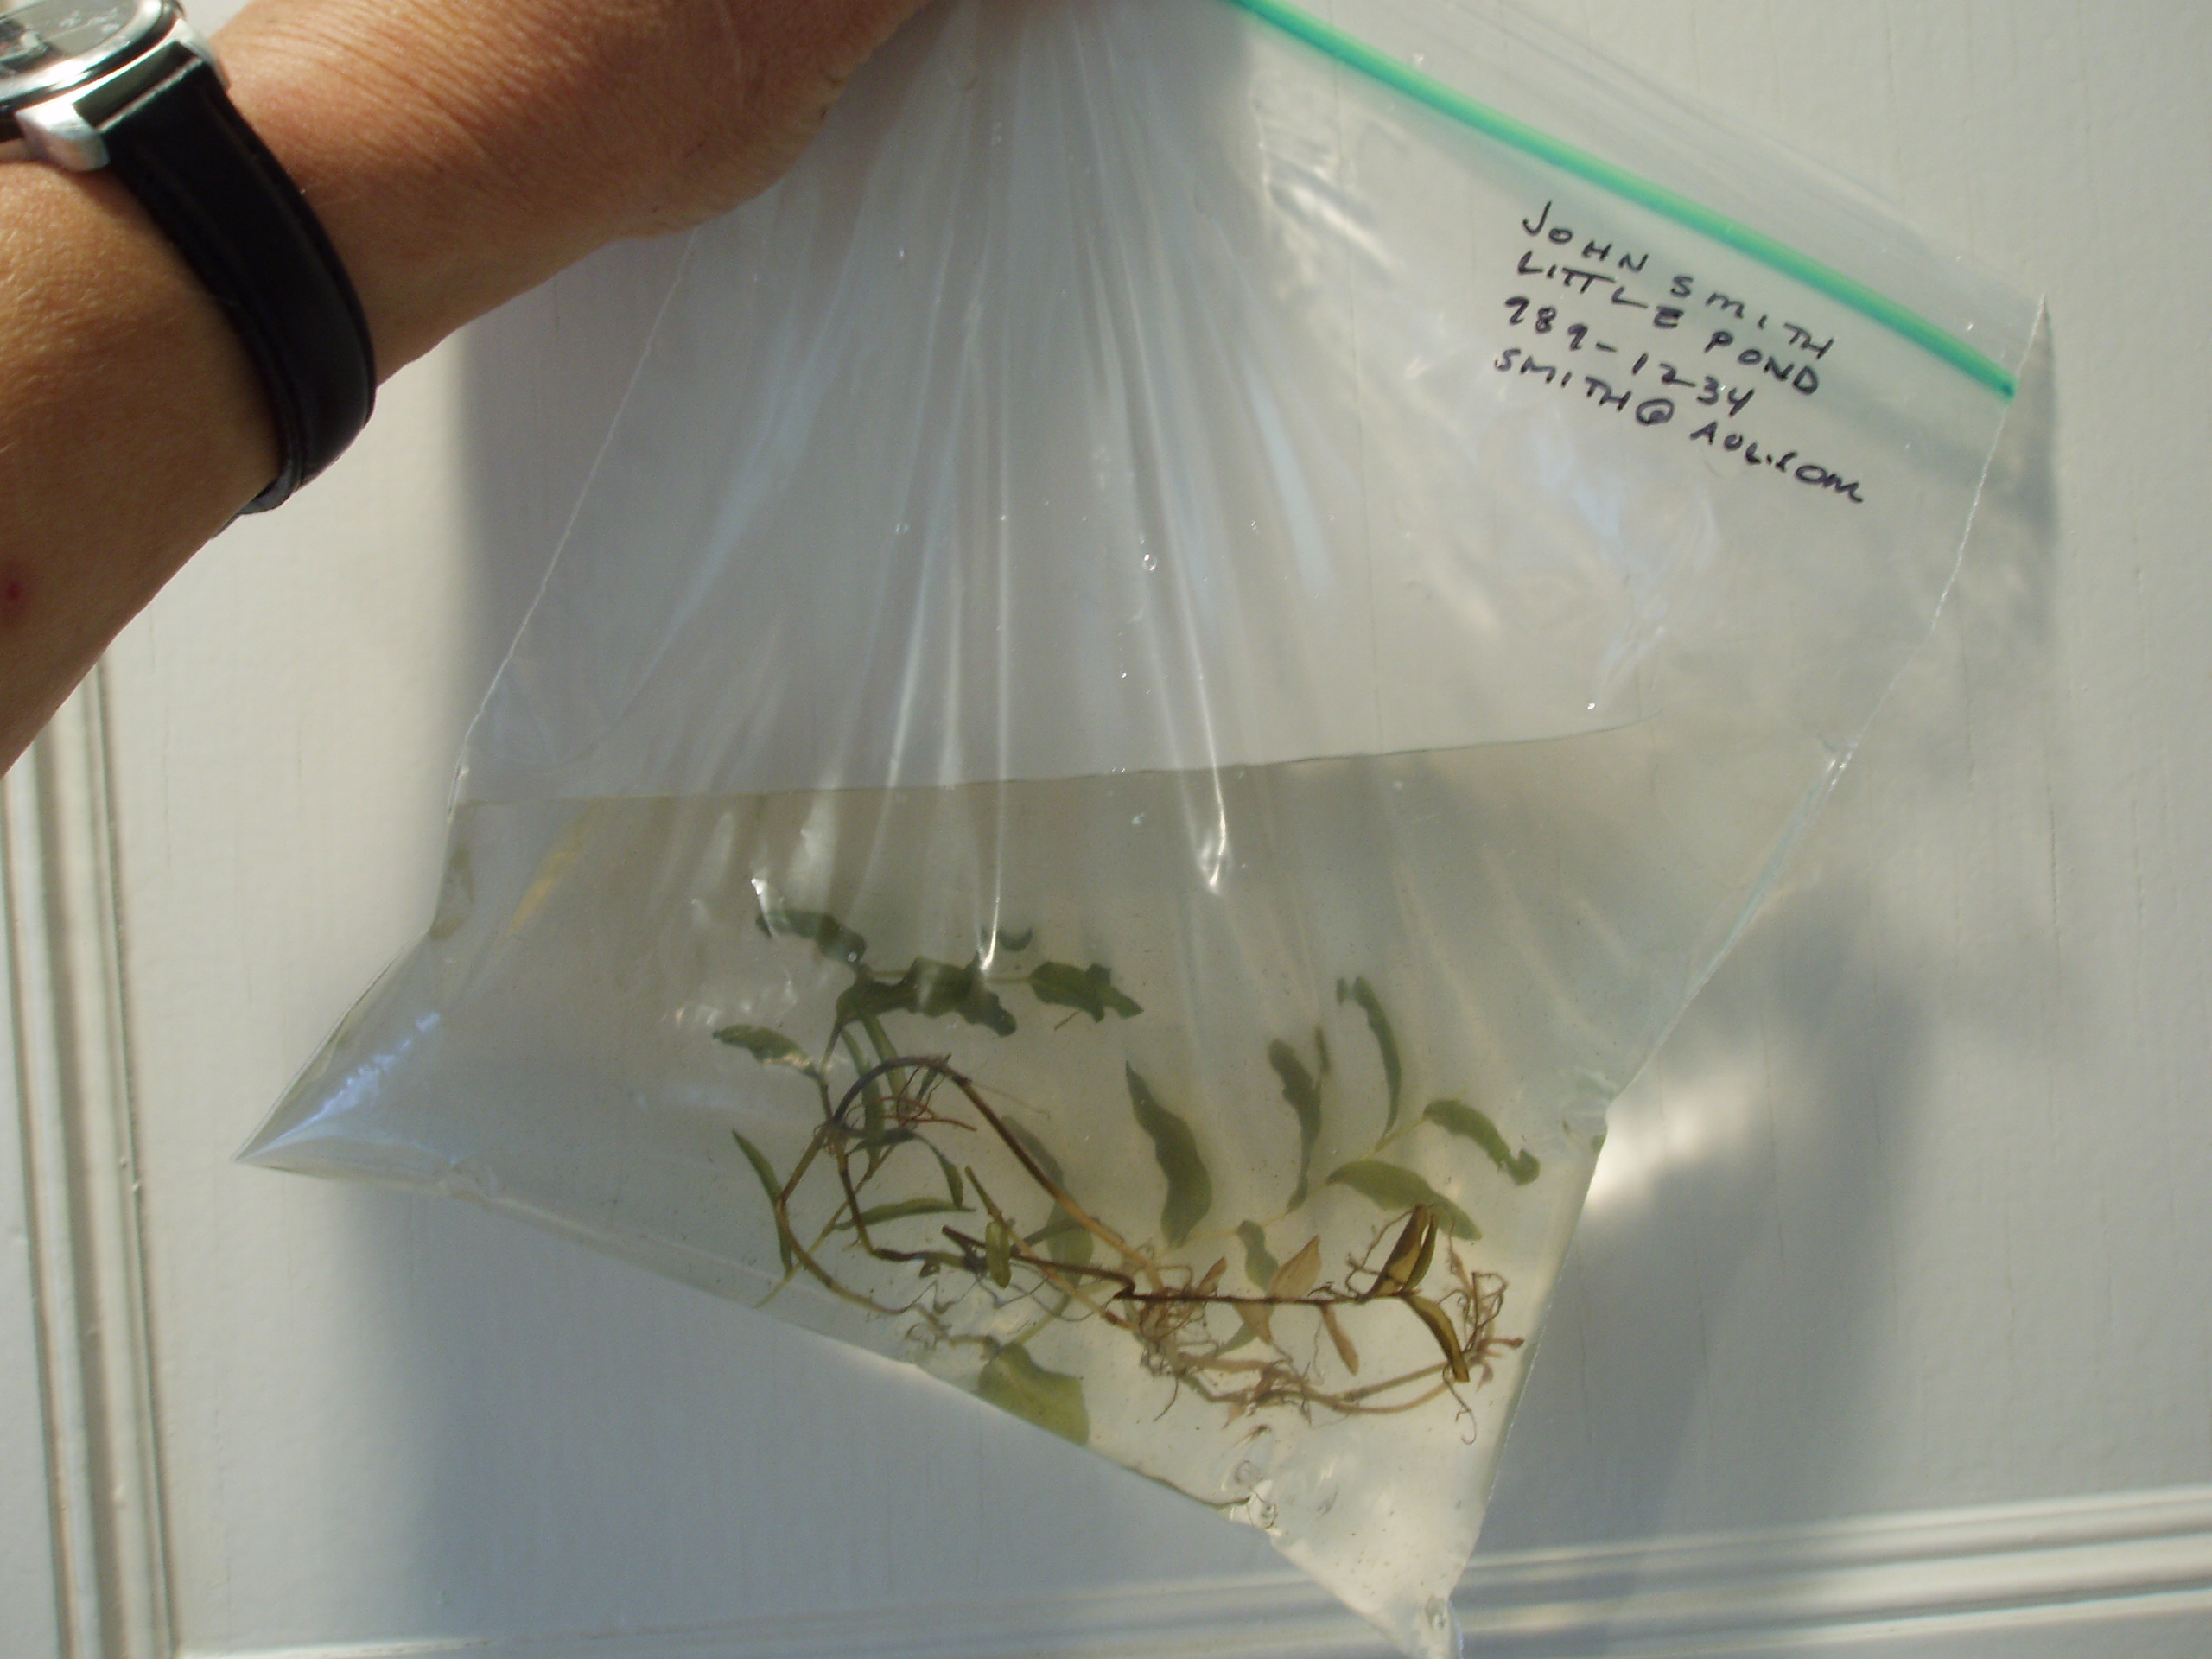
Thank you for helping to keep Maine lakes free of invasive aquatic plants!
Sturdy plant sample packed wet, but without additional water. Remove air from the bag before sealing.
Flimsy plant sample packed in enough clear water to keep hydrated, and to cushion

